**Name: Rabiya Adnan  
Roll Number: 16L-4356  
Section: CS – A**

**Web Programming – Research Assignment  
(Assignment 2)**

**Question 1:  
MongoDB vs Mongoose. Why are we using Mongoose package instead of MongoDB package? How would we perform CRUD operations using the MongoDB package? Give code examples for creating, retrieving, updating and deleting MongoDB documents. (8)**MongoDB is a native driver in node.js to interact with MongoDB.  
Mongoose is an object modelling library that provides rigorous modelling environment for your data. Used to interact with MongoDB, it makes life easier by providing convenience in managing data.   
We’re using mongoose package instead of MongoDB package because it is easier to maintain.  
Using Mongoose, a user can define the schema for the documents in a particular collection. It provides a lot of convenience in the creation and management of data in MongoDB. On the downside, learning mongoose can take some time, and has some limitations in handling schemas that are quite complex.  
However, if your collection schema is unpredictable, or you want a Mongo-shell like experience inside Node.js, then go ahead and use the MongoDB driver. It is the simplest to pick up. The downside here is that you will have to write larger amounts of code for validating the data, and the risk of errors is higher.

CRUD operations using the MongoDB package:

**Create Operation:**  
Inserting documents into a collection:  
db.collection.insertOne()  
db.collection.insertMany()

Db.users.insertOne(  
{  
 name: “sue”,  
 age: 26,  
 status: “pending”  
})

**Read Operation:**db.collection.find()

Db.users.find(

{ age: { $gt: 8} },  
 { name: 1, address: 1 }

).limit(5)

**Update Operation:**db.collection.updateOne()  
db.collection.updateMany()  
db.collection.replaceOne()

db.users.updateMany(

{ age: { $lt: 18 } },  
 { $set: { status: “reject” } }

)

**Delete Operation:**db.collection.deleteOne()  
db.collection.deleteMany()

db.users.deleteMany (

{ status: “reject” }

)

**Question 2:**

**POST vs PUT. Why was POST used to update employee data in the Employees sample AJAX application? What happens if you replace POST with PUT? What difference does it make? (2)**POST is used to create, PUT is used to create and update.  
It would make no difference if we replace post with put, because POST is used to create, while PUT is used to create and update. Hence PUT can do what POST can do.   
Using POST or PUT in your RESTful design is left up to you. However, there are some considerations that you can look into:

* Do you name your URL objects you create explicitly, or let the server decide? If you name them then use PUT. If you let the server decide then use POST.
* You can update or create a resource with PUT with the same object URL
* With POST you can have 2 requests coming in at the same time making modifications to a URL, and they may update different parts of the object.
* If you PUT an object twice, it has no effect. This is a nice property, so I would use PUT when possible.

**Question 3:**

**PUT vs PATCH. Can PUT be used for partial updates e.g. in case of updating your name in an online university application form what method should be used? PUT or PATCH or anyone? Why? (2)**The http PUT method only allows a complete replacement of the document. This proposal adds a new http method, PATCH, to modify an existing http resource. One is for when you know all the answers, and the other is for updating little bits at a time.   
PUT can be used for a partial update, by sending the entire resource with the updated values. However, using PUT for partial updates may lead you to consuming more network bandwidth than necessary.   
In case of updating your name in an online application form, PATCH should be used, since it can be used to update only a specific field instead of the entire document. This also enhances the application performance, since sending updating one field is quicker than updating the entire document.

**Question 4:**

**Where does React lie in comparison to AngularJS? Compare with respect to advantages and disadvantages. (4)**High Scalability  
You can easily gamut Angular. How? All the credit goes to its simple and unique design as well as a solid CLI. While, React is provable that it is reliable and efficient for better workflow. Hence, this framework is very scalable comparatively. And according to Js researches, ReactJs is hits the list when respondents were asked about their satisfaction levels.

Overall Performance  
If we talk about performance, simple recipients in Angular are no more in the picture because these people are called on each service delivery. Thus, it is advisable to optimize BehaviorSubject from ReactJs as it efficiently assists the idea of businesses.

Confidence dose  
From confidence dose I mean dependency injection, which is the heart of debate as it is clashing React model of serviceable programming and stability. However, some sort of dependency injection is inevitable in data binding atmosphere as it assists in detachment where there is no split data coating architecture. More so, Angular serves DI as well and the greatest benefit of the same is it has the capability to include diverse lifecycle for multiple stores.

Well, some of the React models organize some kind of comprehensive app situation that draw to distinct workings, however, it is favorable to the establishment of bugs while vanishing the global situation.

Simple code length  
React is quite simple and easy-to-learn, but it consumes time while setting up a project in React. On the other hand, Angular is not at all easy in any aspects and its natural intricacy creates turmoil as Angular specifically creates third party syntax and stores.

Paradigm complexity  
Angular’s performance is quite susceptible with regards to its goal all because of compare and contrast. Furthermore, in any circumstances, you cannot use big paradigms as it has some pros and cons. The benefits include simple coding and provable, but for the disadvantages, you need to split the objects that you typically use and reconstruct it again. However, React in such scenarios, gives you the authority to elect without any extra performance charge. In the end, the results truly depends whether you are a first-class coder or dreadful.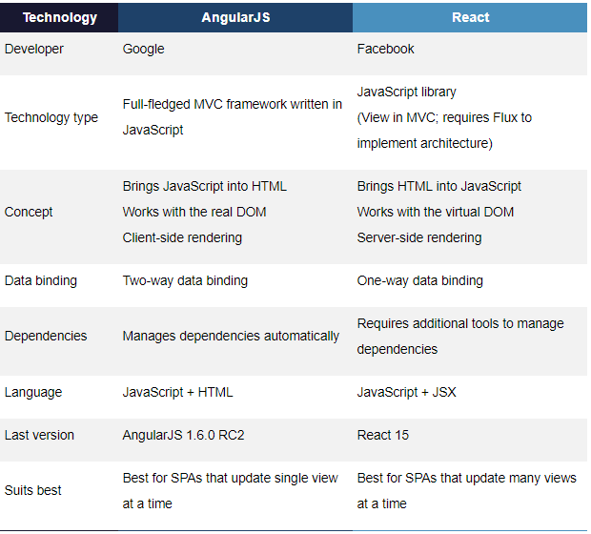

**Question 5:**

**What is Vue.js? Where does Vue lie in comparison to React and AngularJS? Give examples.(4)**Vue.js is an open-source JavaScript framework for building user interfaces and single-page applications.   
The success of JavaScript framework depends on its size. The smaller the size is, the more it will be used. One of the greatest advantages of Vue.js is its small size. The size of this framework is 18-2 KB and it takes no time for user to download and use it. This does not mean that it has low speed because of small size. Instead, it beats all the bulky frameworks like React.js and Angular.js.

* **History of each framework**  
  React is a JavaScript library for building UI components for web applications. React is maintained by Facebook and many leading tech brands are using React in their development environment. React is used by Facebook, Uber, Netflix, Twitter, Paypal, Reddit, Tumblr, WalMart and many more.  
  Angular is a TypeScript-based JvaScript framework backed by Google. It is an enormously popular framework for front-end development. Angular is used by Google, Forbes, WhatsApp, Instagram and many more.   
  Vue.js is one of the most discussed, most rapidly growing JaaScript frameworks. It can be used to build attractive UIs using HTML, CSS and JavaScript. Vue is used by Alibab, GitLab, Baidu, and appreciated by developers and designers globally.
* **Popularity and Market Trends**  
  According to the 2017 Stackoverflow survey, Angular is loved by 51.7% of developers and React is embraced by 66.9% of surveyed developers. React and Angular have almost the same level of users in the category of front-end frameworks. Vue hasn’t occupied a place in any of the above lists but has an ability to participate in this battle.
* **Community Support and Growth**  
  As React is powered by Facebook and Angular is maintained by Google, there’s no doubt on the growth of both of these frameworks. In both frameworks, updates and release are published frequently but they are well maintained when it comes to migrations.   
  If we consider Vue.js in this way, there’s a migration helper tool which makes migration easier. But in the large app, it might cause a problem as there is no proper roadmap which focuses on versioning and their plans.
* **Is it easy to find developers**React involves more JavaScript and sometimes that’s the reason people geared towards Angular or Vue.   
  You can easily find Angular developers and it has a well-established community with lots of projects, updates, resources and a sustainable future.
* **Framework? Library? What’s the difference?**Angular is a framework because it provides you with a good start to build an application with the complete setup. You don’t need to look into libraries, routing solutions, and the structure. You can simply start building. React and Vue, on the other hand, are more flexible and universal than Angular.  
  With React, you can do multiple integrations as you can pair, exchange, and integrate libraries with other great tools out there. At this point, React works out of the box due to its flexibility to offer seamless integration but, with this, there are more chances of to wrong and it requires more dependencies.   
  Vue is the cleanest in comparison to these three frameworks. It helps you keep your code efficient with the perfect balance of internal dependencies and flexibility. It is a very simple, straightforward and easy to use JavaScript framework which aims to simplify web development.
* If you like **flexibility**more than other features, use **React**.
* If you love **coding in TypeScript**, go for **Angular**.
* If you are a **JavaScript lover**, use **React**because it is all about JavaScript.
* If you are a**fan of clean code**, use **Vue**in your application.
* Vue provides the easiest learning curve and it’s an ideal option for beginners.
* If you **want separation of concerns** in your application, use **Vue**.
* If you are a fond of **object-oriented programming**, **Angular** is definitely the pick for you.
* Vue is ideal for a small team and a small project. If your app seems to be large and has significant future expansion plan, pick React or Angular.
* **For cross-platform app development**, **React Native is an ideal choice** as it provides modern functions and you can easily find resources. Angular, on the other side, needs a sound knowledge of JavaScript to build large-scale applications.

**Question 6:**

**How is AngularIO different from AngularJS? Give examples.(4)  
Architecture**Version 1.0 vs. Version 2.0

Angular 2.0 shows a substantial change in the structure as compared to version 1.0. The architecture of Angular v1 is based on MVC whereas the architecture of Angular v2 is based on service/controller. There is very less possibility to upgrade the Angular v1 to v2, mainly developers have to rewrite the entire application code.

Version 2.0 vs. Version 4.0

The upgrade of the version from 2.0 to 4.0 has reduced it’s bundled file size by 60%. The code generated is reduced and has accelerated the application development. Here the developed code can be used for prod mode and debug.

**JavaScript and TypeScript**

v 1.0 vs. v 2.0

Angular v1.0 use JavaScript to build the application while Angular v2.0 uses the Typescript to write the application. TypeScript is a superset of JavaScript which helps to build more robust and structured code. Dart can be used by developers along with TypeScript in version 2.0.

v 2.0 vs. v 4.0

Angular v4.0 is compatible with newer versions TypeScript 2.1 and TypeScript 2.2. This helps with better type checking and also enhanced IDE features for Visual Studio Code.

**Mobile Support**

Angular 2.0 has made it possible to accomplish the native applications for a mobile platform like React Native. Angular 2.0 gives us the two layers: application layer and the rendering layer. As need, any view can be rendered in runtime for the required component.

**Component-based UI**

1.0 vs. 2.0

The controller concept which was present in Angular v1.0 is eliminated in Angular v2.0. Angular v2.0 has changed to component based UI. This helps a developer to divide the applications in terms of components with desired features and enable to call required UI. These have helped to improve the flexibility and reusability as compared to Angular v1.0

**SEO Friendly**

1.0 vs. 2.0

With Angular v1.0 developing the search engine friendly Single Page Applications was the major difficulty. But this bottleneck was eliminated in Angular v2.0. [**AngularJS development services**](https://www.angularminds.com/angularjs-development-company.html) build SEO friendly Single Page Applications by rendering the HTML at the server side.

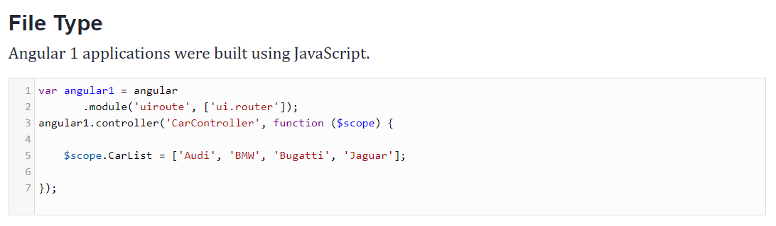

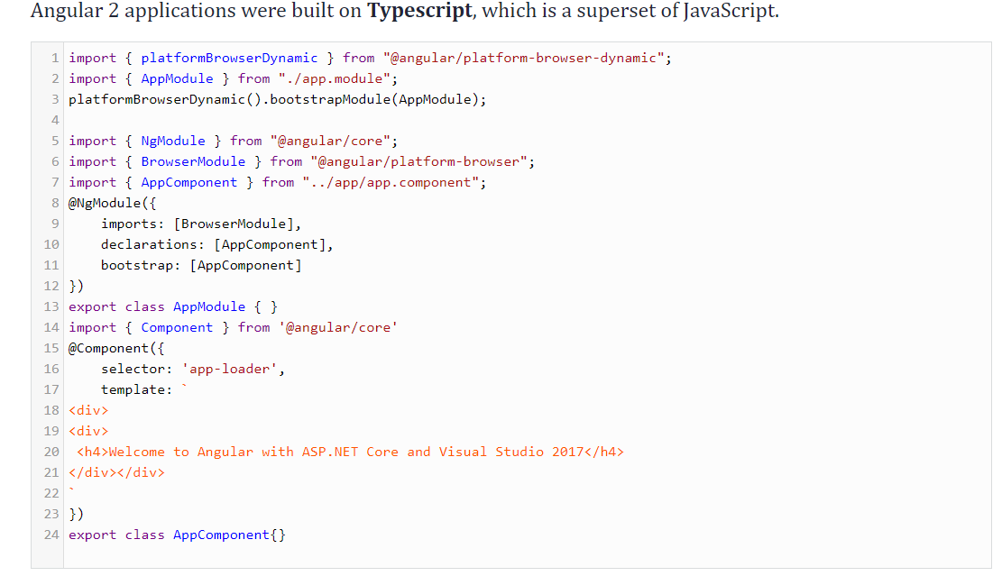

**Question 7:**

**What is Linting? What is the use of JSLint? What is the use of ESLint? Give examples. (4)**Linting is the process of running a program that will analyze code for potential errors.Lint was the name originally given to a particular program that flagged some suspicious and non-portable constructs (likely to be bugs) in C language source code. The term is now applied generically to tools that flag suspicious usage in software written in any computer language.Linting will run through your source code to find

- formatting discrepancy

- non-adherence to coding standards and conventions

- pinpointing possible logical errors in your program

Running a Lint program over your source code, helps to ensure that source code is legible, readable, less polluted and easier to maintain.

JSLint:  
 JSLint is a JavaScript program that looks for problems in JavaScript programs. It is a **static code analysis** tool used in software development for checking if JavaScript source code complies with coding rules.

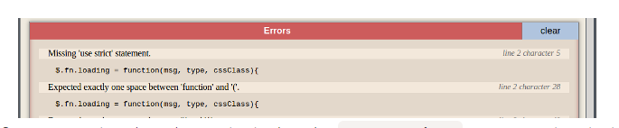

The first error pointed out by JSLint is that the "use strict" statement is missing. This error indicates that the function is not executed in strict mode. To correct this error, enable strict mode by adding the following string literal to the beginning of the function body.

ESLint:  
**ESLint** is a tool for identifying and reporting on patterns found in ECMAScript/**JavaScript** code, with the goal of making code more consistent and avoiding bugs. In many ways, it is similar to JSLint and JSHint with a few exceptions:

•        ESLint uses [Espree](https://github.com/eslint/espree" \t "_blank) for JavaScript parsing.

•        ESLint uses an AST to evaluate patterns in code.

•        ESLint is completely pluggable, every single rule is a plugin and you can add more at runtime.

**Question 8:**

**Give an example where you would prefer to use AngularJS over AJAX and vice versa. (2)**If you just want to add HTTP requests capability to your app just use Ajax. If you want to build complete Single Page Application use Angular (or other web frameworks).  
AngularJS is based on JavaScript. It’s scope in terms of web development is much broader than JQuery. It is a complete framework which would change the way you write your code (both HTML as well as JavaScript).  
AJAX is a JavaScript concept for fetching data from server. There are predefined methods both in Angular as well as JQuery for implementing AJAX.  
AJAX can be used to retrieve data from a web server without reloading the entire page, whereas, AngularJS can be used to build single-age applications (SPAs), for instance, a calculator.